Ex. No: 2 | Docker Container and Images
14-08-2025

Objective

The objective is to understand Docker containers and images by verifying installation, building a
custom image, and deploying a simple web application using Docker.

Tools/ Software Required
• Docker
• Command Line / Terminal
• Code Editor (VS Code / Sublime / Notepad++)
• Web Browser

Industry Relevance and Applications
• Containerization: Runs applications in isolated environments.
• Microservices Architecture: Deploying services in lightweight containers.
• DevOps and CI/CD: Automates build, test, and deployment workflows.
• Portability: Same image runs on multiple environments without compatibility issues.

Description
• This experiment demonstrates:
• Checking Docker Installation
• Running a Test Container
• Building a Custom Docker Image
• Running a Web Application in a Docker Container

• Docker is an open-source platform that enables containerization, a method of packaging
applications along with all their dependencies into lightweight, portable containers. Unlike
virtual machines, containers share the host operating system kernel, making them faster, more
efficient, and less resource-intensive.

• Image and Container Concept: A Docker Image is a read-only template that contains the application code, runtime,
libraries, and configuration files.
• A Docker Container is a running instance of an image that provides an isolated
execution environment.
• Portability: Docker containers ensure the application runs the same way in any environment -
development, testing, or production - eliminating compatibility issues.
• Typical Workflow
1. Developer Stage
Developers write and test code locally. The application code, dependencies, and
configurations are defined in a Dockerfile.

2. Docker Build Stage
The docker build command creates an image from the Dockerfile. This image serves as
the base for creating containers.
3. CI/CD Pipeline Integration
Continuous Integration and Continuous Deployment (CI/CD) pipelines automate the
build and deployment process.
• Build: The pipeline creates the image whenever new code is pushed to the repository.
• Test: Automated tests validate the container before deployment.
• Push: The tested image is pushed to a container registry like Docker Hub.
4. Deployment Anywhere
Once the image is in the registry, it can be deployed on any infrastructure:
• Cloud Platforms: AWS, Azure, Google Cloud
• On-Premise Systems: Local servers
• Orchestrators: Kubernetes, Docker Swarm for managing multiple containers
• Tools like Ansible, Helm, and Terraform are used for automated deployment and scaling.

Command list with explanation

Command | Command
Description | Description
docker –version | docker –version
Checks installed Docker version. | Checks installed Docker version.
docker run hello-world | docker run hello-world
Runs a test container to verify Docker setup. | Runs a test container to verify Docker setup.

Procedure
1. Check Docker Installation by running : docker --version
2. Run Test Container using : docker run hello-world
3. Create Project Folder
mkdir docker-demo
cd docker-demo
4. Create a Web Page (index.html)
5. Create a Dockerfile
6. Build Docker Image using: docker build -t myweb:v1 .
7. Run Docker Container using: docker run -d -p 8080:80 myweb:v1

Prerequisites
- Docker Hub account
- Git installed locally
- Python 3.11+
- Docker Desktop (optional for local testing)

Output

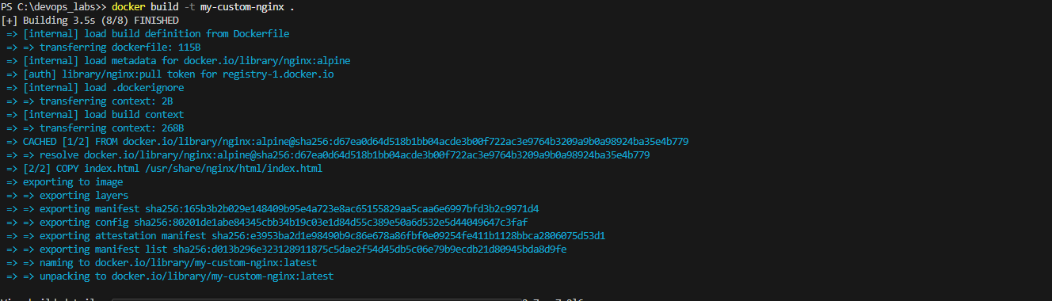

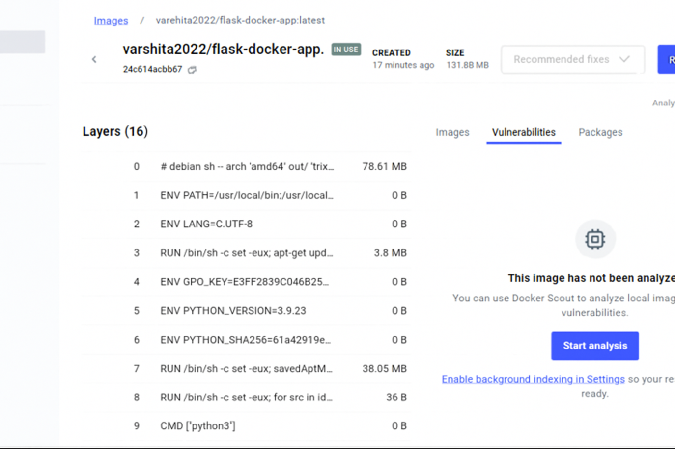

Result
Docker installation was verified, a custom image was built, and a containerized web application was
successfully deployed.

